CTE
Quick Reference Guide

Flowcharts and Pathways
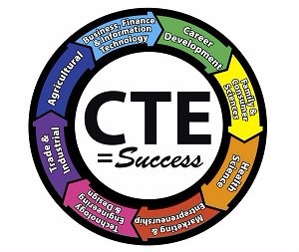

Effective Fall 2020

It is the policy of Crosby ISD not to discriminate on the basis of race, color, national origin, sex or handicap in its vocational programs, services or activities as required by Title VI of the Civil Rights Act of 1964, as amended; Title IX of the Education Amendments of 1972; and Section 504 of the Rehabilitation Act of 1973, as amended.

This Page is Intentionally Left Blank

Table of Contents
CTE Program of Study | Page # | CTE Program of Study | Page #
Agriculture, Food, and Natural Resources |  | Energy
Flowchart | 6 | Flowchart | 34
Pathway Description by Grade | 7 | Pathway Description by Grade | 35
Pathway Course Descriptions | 8-9 | Pathway Course Descriptions | 36
Architecture and Construction |  | Health Science
Flowchart | 12 | Flowchart | 38
Pathway Description by Grade | 13 | Pathway Description by Grade | 39
Pathway Course Descriptions | 14-15 | Pathway Course Descriptions | 40-42
Arts, Audio Video Technology and Communications |  | Hospitality and Tourism
Flowchart | 18 | Flowchart | 44
Pathway Description by Grade | 19 | Pathway Description by Grade | 45
Pathway Course Descriptions | 20-21 | Pathway Course Descriptions | 46
Business, Marketing & Finance |  | Human Services
Flowchart | 24 | Flowchart | 48
Pathway Description by Grade | 25 | Pathway Description by Grade | 49
Pathway Course Descriptions | 26-27 | Pathway Course Descriptions | 50
Education and Training |  | Law and Public Service
Flowchart | 30 | Flowchart | 52
Pathway Description by Grade | 31 | Pathway Description by Grade | 53
Pathway Course Descriptions | 32 | Pathway Course Descriptions | 54
CTE Program of Study | Page #
Manufacturing (Welding)
Flowchart | 56
Pathway Description by Grade | 57
Pathway Course Descriptions | 58
STEM Manufacturing (Robotics)
Flowchart | 60
Pathway Description by Grade | 61
Pathway Course Descriptions | 62
STEM Computer Programming
Flowchart | 64
Pathway Description by Grade | 65
Pathway Course Descriptions | 66
Transportation, Distribution & Logistics
Flowchart | 68
Pathway Description by Grade | 69
Pathway Course Descriptions | 70-71

Endorsement: Business and Industry

CTE Cluster: Agriculture, Food, and Natural Resources

CTE Pathways:
Veterinary Assistant Pathway
Floral Design Pathway
Landscape Pathway
Agriculture Mechanics and Engineering Pathway

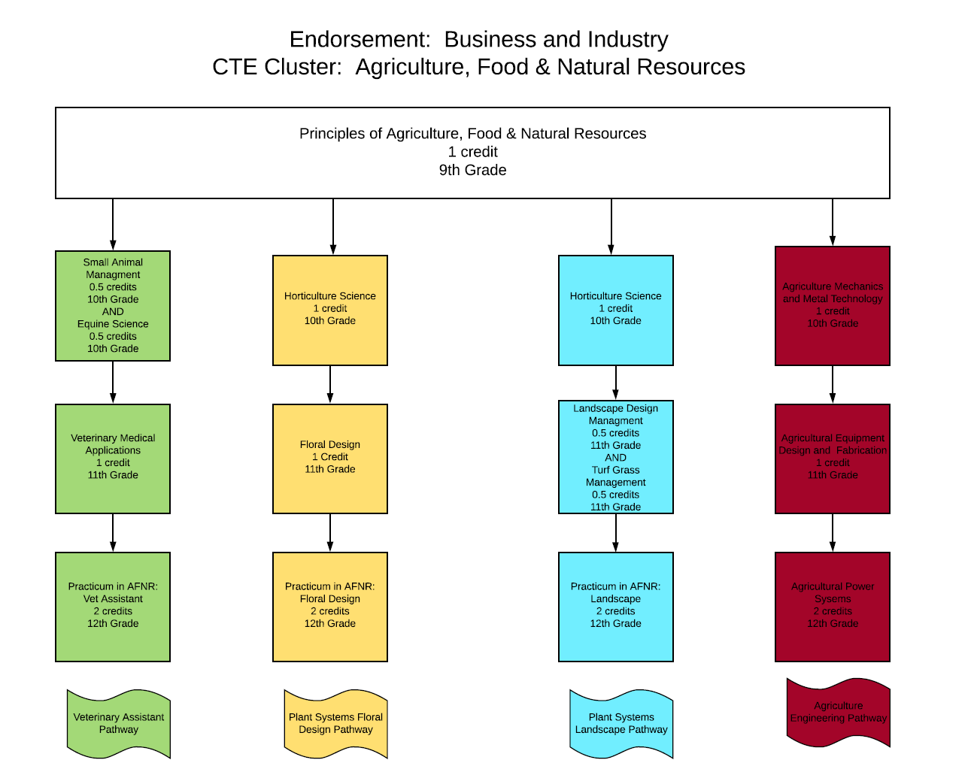

Endorsement: Business and Industry
CTE Cluster: Agriculture, Food, and Natural Resources

 | Animal Systems Pathway | Plant Systems Floral Pathway | Plant Systems Landscape Pathway | Agriculture Engineering Pathway
9th Grade | Principles of Agriculture, Food, & Natural Resources  (1 credit) | Principles of Agriculture, Food, & Natural Resources  (1 credit) | Principles of Agriculture, Food, & Natural Resources  (1 credit) | Principles of Agriculture, Food, & Natural Resources  (1 credit)
10th Grade | Small Animal Management (.5 credit) and Equine Science (.5 credit) | Horticulture Science  (1 credit) | Horticulture Science  (1 credit) | Agriculture Mechanics and Metal Technology  (1 credit)
11th Grade | Veterinary Medical Applications  (1 credit) | Floral Design  (1 credit) | Landscape Design Management (.5 credit)  And  Turf Grass Mgmt. (.5 credit) | Agricultural Equipment Design and Fabrication Lab  (1 credit)
12th Grade | Practicum in Ag: Veterinary Assistant  (2 credits) | Advanced Floral Design  (1 credits) | Practicum in Ag: Landscape  (2 credits) | Agricultural Power Systems  (2 credits)
Additional Courses | Wildlife, Fisheries, & Ecology Management  (1 credit)  Livestock Production  (1credit)  Advanced Animal Science  (1 credit) | Landscape Design Management (.5 credit)  And  Turf Grass Mgmt. (.5 credit) | Range, Ecology Management  (1 credit) | Agriculture Equipment Design  (1 credit)
Certifications | Certified Veterinary Assistant Level 1 | Texas Floral Association Level 1 Certification | Commercial Pesticide Applicator License | NCCER Safety, AWS Welding

Endorsement: Business and Industry
CTE Cluster: Agriculture, Food, and Natural Resources Course Descriptions

9th Grade Options:
- Principles of Agriculture, Food, and Natural Resources will allow students to develop knowledge and skills regarding career and educational opportunities, personal development, globalization, industry standards, details, practices, and expectations.
Credit: 1 Prerequisite: None

10th Grade Options:
- Small Animal Management will allow students to acquire knowledge and skills related to small animals and the small animal management industry. Small Animal Management may address topics related to small mammals such as dogs and cats, amphibians, reptiles, and birds.
Credit: 0.5 Prerequisite: Principles of Agriculture, Food, & Natural Resources or Intro to Ag
- Equine Science will allow students to acquire knowledge and skills related to equine animal systems and the equine industry. Equine Science may address topics related to horses, donkeys, and mules.
Credit: 0.5 Prerequisite: Principles of Agriculture, Food, & Natural Resources or Intro to Ag
- Horticultural Science is designed to develop an understanding of common horticultural management practices as they relate to food and ornamental plant production.
Credit: 1 Prerequisite: Principles of Agriculture, Food, & Natural Resources or Intro to Ag
- Agricultural Mechanics and Metal Technologies is designed to develop an understanding of agricultural mechanics as it relates to safety and skills in tool operation, electrical wiring, plumbing, carpentry, fencing, concrete, and metal working techniques. To prepare for careers in agricultural power, structural, and technical systems, students must attain academic skills and knowledge; acquire technical knowledge and skills related to power, structural, and technical agricultural systems and the industry; and develop knowledge and skills regarding career opportunities, entry requirements, industry certifications, and industry expectations.
Credit: 1 Prerequisite: Principles of Agriculture, Food, & Natural Resources or Intro to Ag

11th Grade Options:
- Veterinary Medical Applications covers topics relating to veterinary practices, including practices for large and small animal species.
Credit: 1 Prerequisite: Small Animal Management
- Floral Design is designed to develop students' ability to identify and demonstrate the principles and techniques related to floral design as well as develop an understanding of the management of floral enterprises. Through the analysis of artistic floral styles and historical periods, students will develop respect for the traditions and contributions of diverse cultures. Students will respond to and analyze floral designs, thus contributing to the development of lifelong skills of making informed judgments and evaluations. This class satisfies the Fine Art credit requirement for graduation.
Credit: 1 Prerequisite: Principles of Agriculture, Food, & Natural Resources or Intro to Ag
- Landscape Design and Management is designed to develop an understanding of landscape design and management techniques and practices. To prepare for careers in horticultural systems, students must attain academic skills and knowledge, acquire technical knowledge and skills related to horticultural systems and the workplace, and develop knowledge and skills regarding career opportunities, entry requirements, and industry expectations.
Credit: 0.5 Prerequisite: Horticultural Science

- Turf Grass Management is designed to develop an understanding of turf grass management techniques and practices.
Credit: 0.5 Prerequisite: Horticultural Science

- Agricultural Power Systems is designed to develop an understanding of power and control systems as related to energy sources, small and large power systems, and agricultural machinery. To prepare for careers in agricultural power, structural, and technical systems, students must attain academic skills and knowledge; acquire technical knowledge and skills related to power, structural, and technical agricultural systems and the workplace; and develop knowledge and skills regarding career opportunities, entry requirements, industry certifications, and industry expectations.
Credit: 1 Prerequisite: Agricultural Mechanics and Metal Technologies

12th Grade Options:
- Practicum in Agriculture, Food, and Natural Resources: Veterinary Assistant is designed to give students supervised practical application of knowledge and skills. Students will have a combination of classroom and internship experience with a veterinary clinic. Students will prepare for and take the Certified Veterinary Assistant certification exam that will allow them to get a job as a Veterinary Assistant at the conclusion of the course.
Credit: 1 Prerequisite: Veterinary Medical Applications
- Advanced Floral Design is designed to allow students to improve upon their floral design techniques and learn the business aspects of the floral industry. Emphasis will be placed on difficult techniques such as designing wedding flowers. Students will learn business practices such as developing a customer base, planning and ordering cut flowers, and scheduling for holiday work.
Credit: 1 Prerequisite: Floral Design
- Practicum in Agriculture, Food, and Natural Resources: Landscape is designed to give students supervised practical application of knowledge and skills. Students will have a combination of classroom experiences, independent study, and internship experiences. Students will have the opportunity to earn their Commercial/Noncommercial Pesticide Applicator License at the completion of the course.
Credit: 1 Prerequisite: Turf Grass Management and Landscape Management
- Agricultural Equipment Design and Fabrication will allow students to acquire knowledge and skills related to the design and fabrication of agricultural equipment.
Credit: 1 Prerequisite: Agricultural Power Systems

Additional Course Options 10-12
- Wildlife, Fisheries, and Ecology Management examines the management of game and non-game wildlife species, fish, and aqua crops and their ecological needs as related to current agricultural practices. To prepare for success, students need opportunities to learn, reinforce, apply, and transfer their knowledge and skills in a variety of settings.
Credit: 1 Prerequisite: Principles of Agriculture, Food, & Natural Resources or Intro to Ag
- Advanced Animal Science examines the interrelatedness of human, scientific, and technological dimensions of livestock production. Instruction is designed to allow for the application of scientific and technological aspects of animal science through field and laboratory experiences.
- Credit: 1 Prerequisite: Biology & Chemistry or IPC, Algebra I, Principles of Ag or Intro to Ag, Small Animal Management, and Equine Science
- Livestock Production allows students to acquire knowledge and skills related to livestock and the livestock production industry. Livestock Production may address topics related to beef cattle, dairy cattle, swine, sheep, goats, and poultry.
Credit: 1 Prerequisite: Principles of Agriculture, Food, & Natural Resources or Intro to Ag
- Range Ecology and Management is designed to develop students' understanding of rangeland ecosystems and sustainable forage production.
Credit: 1 Prerequisite: Principles of Agriculture, Food, & Natural Resources or Intro to Ag
- Agriculture Equipment Design allows students to acquire knowledge and skills related to the design and fabrication of agricultural equipment.
Credit: 1 Prerequisite: Principles of Agriculture, Food, & Natural Resources or Intro to Ag, Agriculture Mechanics and Metal Technologies

This Page is Intentionally Left Blank

Endorsement: Business and Industry

CTE Cluster: Architecture and Construction

CTE Pathways:
Commercial Air Conditioning Pathway
Electrical Pathway
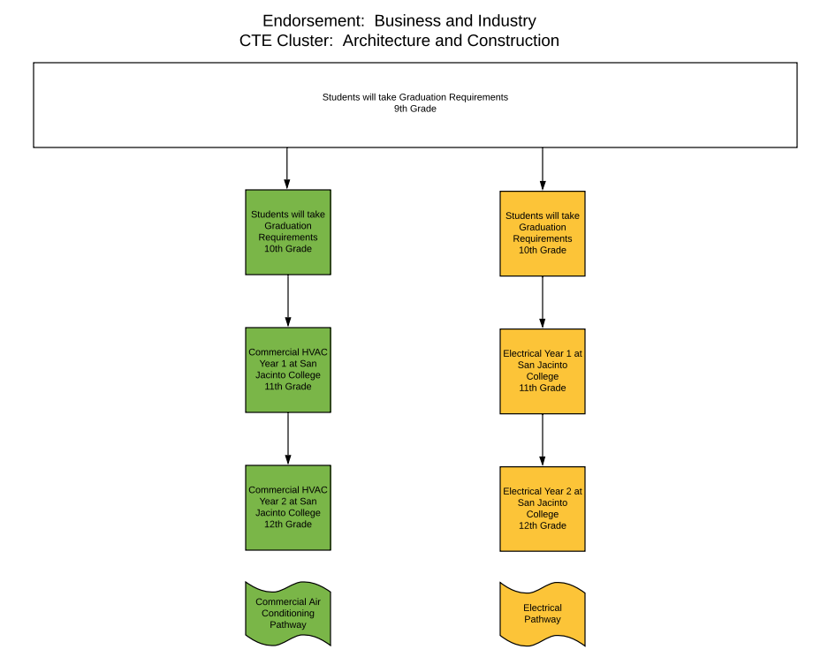

Endorsement: Business and Industry
CTE Cluster: Architecture and Construction

 | Commercial Air Conditioning Pathway | Electrical Pathway
9th Grade | Students will take Graduation Requirements | Students will take Graduation Requirements
10th Grade | Students will take Graduation Requirements | Students will take Graduation Requirements
11th Grade | Commercial Air Conditioning Program Year 1 | Electrical Program Year 1
12th Grade | Commercial Air Conditioning Program Year 2 | Electrical Program Year 2
Additional Courses
Certifications

CTE Cluster: Architecture and Construction Course Descriptions

9th Grade Options:
Students will take electives needed to meet graduation requirements

10th Grade Options:
Students will take electives needed to meet graduation requirements

11th Grade Options:
- Commercial Air Conditioning Program Year 1 allows students to earn 16 college credits by taking the following classes:
HART 1401 | Basic Electricity for HVAC | 4
HART 1407 | Refrigeration Principles | 4
HART 2441 | Commercial Air Conditioning | 4
HART 1445 | Gas and Electrical Heating | 4
Credit: 2 Prerequisite: Acceptance into San Jacinto College’s Commercial Air Conditioning Technology Program
- Electrical Technology Program Year 1 allows students to earn 16 college credits by taking the following classes:
ELPT 1215 | Electrical Calculations I | 2
CETT 1302 | Electricity Principles | 3
ELPT 1325 | National Electric Code I | 3
ELPT 1429 | Residential Wiring | 4
ELPT 1345 | Commercial Wiring | 3
ELPT 2215 | Electrical Calculations II | 2
Credit: 3 Prerequisite: Acceptance into San Jacinto College’s Electrical Technology Program

12th Grade Options:
- Commercial Air Conditioning Program Year 1 allows students to earn 16 college credits by taking the following classes:
HART 2331 | Advanced Electricity for HVAC | 3
HART 2336 | Air Conditioning Troubleshooting | 3
HART 2301 | Air Conditioning and Refrigeration Codes | 3
HART 2442 | Commercial Refrigeration | 4
HART 2368  or HART 2338 | Practicum (or Field Experience) - HVAC/R Technology/Technician  or Air Conditioning Installation and Startup | 3
Credit: 4 Prerequisite: Acceptance into San Jacinto College’s Commercial Air Conditioning Technology Program and Commercial Air Conditioning Program Year 1 courses

- Electrical Technology Program Year 1 allows students to earn 16 college credits by taking the following classes:
ELPT 1351 | Electrical Machines | 3
ELPT 1441 | Motor Control | 4
ELPT 2325 | National Electrical Code II | 3
ELPT 2343 | Electrical System Design | 3

Credit: 4 Prerequisite: Acceptance into San Jacinto College’s Electrical Technology Program and Electrical Technology Program Year 1 courses

This Page is Intentionally Left Blank

Endorsement: Business and Industry

CTE Cluster: Arts, Audio Video, and Communications

CTE Pathways:
Audio Video Production Pathway
Graphic Design (Yearbook) Pathway
Commercial Photography Pathway

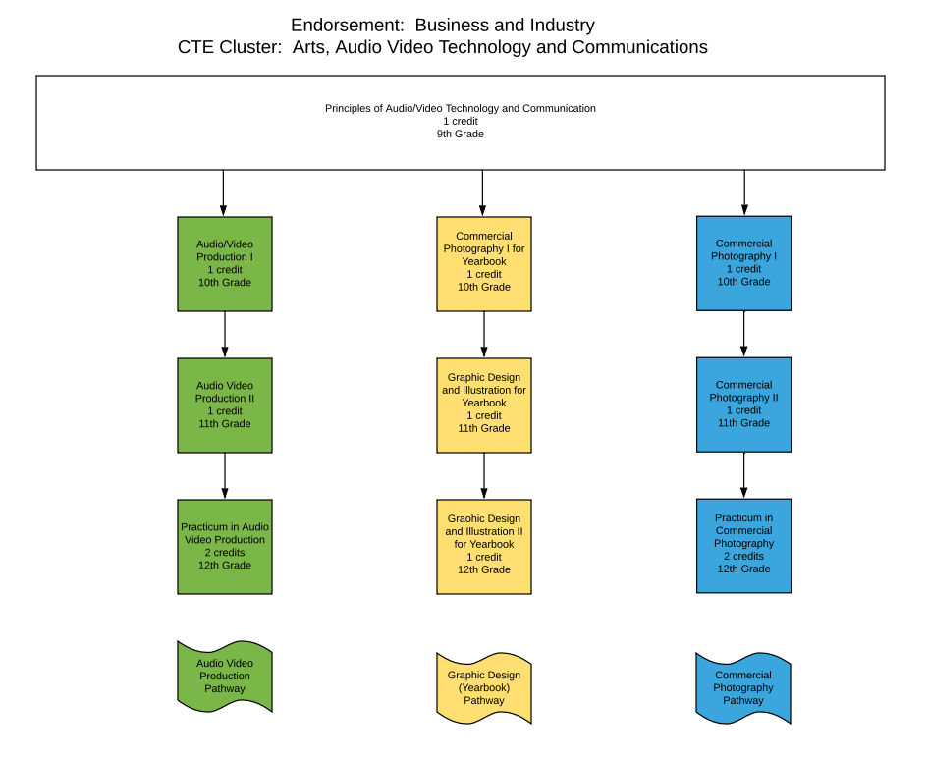

Endorsement: Business and Industry
CTE Cluster: Arts, Audio Video Technology and Communications

 | Audio Video Production Pathway | Graphic Design (Yearbook) Pathway | Commercial Photography Pathway
9th Grade | Principles of Audio/Video Technology and Communication  (1 credit) | Principles of Audio/Video Technology and Communication  (1 credit) | Principles of Audio/Video Technology and Communication  (1 credit)
10th Grade | Audio Video Production I  (1 credit) | Commercial Photography I for Yearbook  (1 credit) | Commercial Photography I  (1 credit)
11th Grade | Audio Video Production II  (1 credit) | Graphic Design and Illustration I (Yearbook)  (1 credit) | Commercial Photography II  (1 credit)
12th Grade | Practicum in Audio Video Production  (2 credits) | Graphic Design and Illustration II (Yearbook)  (1 credit) | Practicum in Commercial Photography  (2 credits)
Additional Courses | Video Game Design  (1 credit) | Video Game Design  (1 credit) | Video Game Design  (1 credit)
Certifications | Adobe Certified Associate | Adobe Certified Associate (In Design) | Adobe Certified Associate (In Design)

CTE Cluster: Arts, Audio Video Technology & communications Course Descriptions

9th Grade Options:
- Principles of Audio Video Technology and Communication enables students to understand arts, audio/video technology, and communications systems. Within this context, students will be expected to develop an understanding of the various and multifaceted career opportunities in this cluster and the knowledge, skills, and educational requirements for those opportunities.
Credit: 1 Prerequisite: None

10th Grade Options:
- Audio Video Production I will allow students to develop the technical knowledge and skills needed for success in the Arts, Audio/Video Technology, and Communications Career Cluster. Students will be expected to develop an understanding of the industry with a focus on pre-production, production, and post-production audio and video products.
Credit: 1 Prerequisite: Principles of Audio Video Technology and Communications
- Commercial Photography I will allow students to develop the knowledge and skills needed for success in the Arts, Audio/Video Technology, and Communications Career Cluster, students will be expected to develop an understanding of the commercial photography industry with a focus on creating quality photographs.
Credit: 1 Prerequisite: Principles of Audio Video Technology and Communications

11th Grade Options:
- Audio Video Production II will allow students to develop the advanced knowledge and skills needed for success in the Arts, Audio/Video Technology, and Communications Career Cluster, students will be expected to develop an advanced understanding of the industry with a focus on pre-production, production, and post-production products.
Credit: 1 Prerequisite: Audio Video Production I
- Graphic Design and Illustration I will allow students to develop the knowledge and skills needed for success in the Arts, Audio/Video Technology, and Communications Career Cluster, students will be expected to develop an understanding of the industry with a focus on fundamental elements and principles of visual art and design.
Credit: 1 Prerequisite: Commercial Photography I
- Commercial Photography II will allow students to develop an advanced technical understanding of the commercial photography industry with a focus on producing, promoting, and presenting professional quality photographs.
- Credit: 1 Prerequisite: Commercial Photography I

12th Grade Options:
- Practicum in Audio Video Production will allow students to develop the advanced technical knowledge and skills needed for success in the Arts, Audio/Video Technology, and Communications Career Cluster, students will be expected to develop an increasing understanding of the industry with a focus on applying pre-production, production, and post-production audio and video products in a professional environment.
Credit: 2 Prerequisite: Audio Video Production II

- Graphic Design and Illustration II will allow students to develop an advanced understanding of the industry with a focus on mastery of content knowledge and skills.
Credit: 1 Prerequisite: Graphic Design and Illustration
- Practicum in Commercial Photography will allow students to develop an advanced technical understanding of the commercial photography industry with a focus on producing, promoting, and presenting professional quality photographs.
Credit: 1 Prerequisite: Graphic Design and Illustration I
- Practicum in Commercial Photography will allow students to develop an advanced technical understanding of the commercial photography industry with a focus on producing, promoting, and presenting professional quality photographs.
Credit: 2 Prerequisite: Commercial Photography II

Additional Course Options 10-12
- Video Game Design allows students to explore one of the largest industries in the global marketplace and the new emerging careers it provides in the field of technology. Students will learn gaming, computerized gaming, evolution of gaming, artistic aspects of perspective, design, animation, technical concepts of collision theory, and programming logic. Students will participate in a simulation of a real video game design team while developing technical proficiency in constructing an original game design.
Credit: 1 Prerequisite: Principles of Audio Video Technology and Communications

This Page is Intentionally Left Blank

Endorsement: Business and Industry

CTE Cluster: Business, Marketing, and Finance

CTE Pathways:
Accounting Pathway
Entrepreneurship Pathway

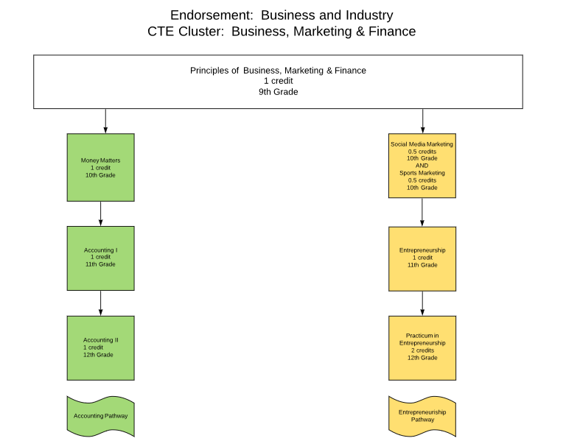

Endorsement: Business and Industry
CTE Cluster: Business, Marketing, and Finance

 | Accounting Pathway | Marketing Pathway
9th Grade | Principles of Business, Marketing, and Finance  (1 credit) | Principles of Business, Marketing, and Finance  (1 credit)
10th Grade | Money Matters  (1 credit) | Social Media Marketing  (.5 credit)  And  Sports Marketing (.5 credit)
11th Grade | Accounting I  (1 credit) | Entrepreneurship  (1 credit)
12th Grade | Accounting II  (1 credit) | Practicum in Entrepreneurship  (2 credits)
Additional Courses | Financial Math  (1 credit)  Banking & Financial Services  (1 credit) | Business Management  (1 credit)
Certifications | Intuit Quickbooks Certified User | Microsoft Office Specialist

CTE Cluster: Business, Marketing & Finance Course Descriptions

9th Grade Options:
- Principles of Business, Marketing & Finance enables students to gain knowledge and skills in economies and private enterprise systems, the impact of global business, the marketing of goods and services, advertising, and product pricing. Students analyze the sales process and financial management principles. This course allows students to reinforce, apply, and transfer academic knowledge and skills to a variety of interesting and relevant activities, problems, and settings in business, marketing, and finance.
Credit: 1 Prerequisite: None

10th Grade Options:
- Money Matters allows students to investigate money management from a personal financial perceptive. Students will apply critical-thinking skills to analyze financial options based on current and projected economic factors. Students will gain knowledge and skills necessary to establish short-term and long-term financial goals. Students will examine various methods of achieving short-term and long-term financial goals through various methods such as investing, tax planning, asset allocating, risk-management, retirement planning, and estate planning.
Credit: 1 Prerequisite: Principles of Business, Marketing & Finance
- Social Media Marketing is designed to look at the rise of social media and how marketers are integrating social media tools in their overall marketing strategy. The course will investigate how the marketing community measures success in the new world of social media. Students will manage a successful social media presence for an organization, understand techniques for gaining customer and consumer buy-in to achieve marketing goals, and properly select social media platforms to engage consumers and monitor and measure the results of these efforts.
Credit: .5 Prerequisite: Principles of Business, Marketing & Finance
- Sports and Entertainment Marketing will provide students with a thorough understanding of the marketing concepts and theories that apply to sports and entertainment. The areas this course will cover include basic marketing concepts, publicity, sponsorship, endorsements, licensing, branding, event marketing, promotions, and sports and entertainment marketing strategies.
Credit: .5 Prerequisite: Principles of Business, Marketing & Finance

11th Grade Options:
- Accounting I will allow students to investigate the field of accounting, including how it is impacted by industry standards as well as economic, financial, technological, international, social, legal, and ethical factors. Students will reflect on this knowledge as they engage in the process of recording, classifying, summarizing, analyzing, and communicating accounting information. Students will formulate and interpret financial information for use in management decision making. Accounting includes such activities as bookkeeping, systems design, analysis, and interpretation of accounting information.
Credit: 1 Prerequisite: Principles of Business, Marketing & Finance
- Entrepreneurship will allow students to develop the knowledge and skills needed for success in the Arts, Audio/Video Technology, and Communications Career Cluster, students will be expected to develop an understanding of the industry with a focus on fundamental elements and principles of visual art and design.
Credit: 1 Prerequisite: Social Media Marketing and Sports and Entertainment Marketing

12th Grade Options:
- Accounting II allows students to continue the investigation of the field of accounting, including how it is impacted by industry standards as well as economic, financial, technological, international, social, legal, and ethical factors. Students will reflect on this knowledge as they engage in various managerial, financial, and operational accounting activities. Students will formulate, interpret, and communicate financial information for use in management decision making. Students will use equations, graphical representations, accounting tools, spreadsheet software, and accounting systems in real-world situations to maintain, monitor, control, and plan the use of financial resources.
Credit: 1 Prerequisite: Accounting I
- Practicum in Entrepreneurship will allow students to develop the knowledge and skills needed for success in an entrepreneurial setting. This course integrates the skills and knowledge students have learned in entrepreneurship and apply them in an entrepreneurial setting. Since much of this course involves interaction with the business community, students are expected to represent yourself professionally. This includes showing up, on time, to every scheduled “business meeting” fully prepared and ready to expand and share your knowledge and skills. A key to entrepreneurial success is the ability to gather, interpret and retain information utilizing the acquired knowledge towards action. With respect to this approach, all students will be expected to think in entrepreneurial terms.
Credit: 2 Prerequisite: Entrepreneurship

Additional Course Options 10-12
- Financial Math is a course about personal money management. Students will apply critical-thinking skills to analyze personal financial decisions based on current and projected economic factors.
Credit: 1 Prerequisite: Algebra I
- Banking and Financial Services enables students will develop knowledge and skills in the economic, financial, technological, international, social, and ethical aspects of banking to become competent employees and entrepreneurs. Students will incorporate a broad base of knowledge that includes the operations, sales, and management of banking institutions to gain a complete understanding of how banks function within society.
Credit: 1 Prerequisite: Principles of Business, Marketing & Finance
- Business Management is designed to familiarize students with the concepts related to business management as well as the functions of management, including planning, organizing, staffing, leading, and controlling. Students will also demonstrate interpersonal and project-management skills.
Credit: 1 Prerequisite: Principles of Business, Marketing & Finance

This Page is Intentionally Left Blank

Endorsement: Public Service

CTE Cluster: Education and Training

CTE Pathways:
Education and Training Pathway

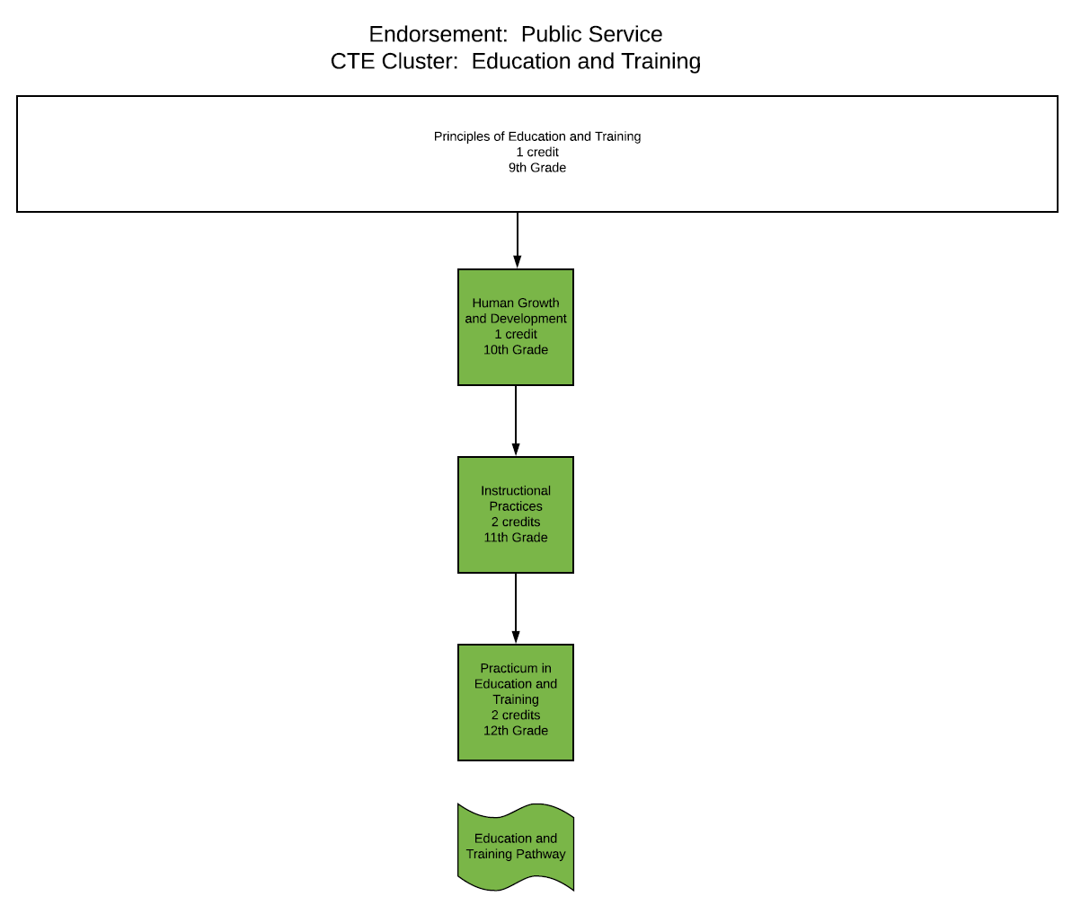

Endorsement: Public Service
CTE Cluster: Education and Training

 | Education and Training Pathway
9th Grade | Principles of Education and Training  (1 credit)
10th Grade | Human Growth and Development  (1 credit)
11th Grade | Instructional Practices  (2 credits)
12th Grade | Practicum in Education and Training  (2 credits)
Additional Courses
Certifications | Educational Aid or Child Development Associate

CTE Cluster: Education and Training Course Descriptions

9th Grade Options:
- Principles of Education and Training introduces students to the various careers available within the Education and Training Career Cluster. Students use self-knowledge as well as educational and career information to analyze various careers within the Education and Training Career Cluster. Students will develop a graduation plan that leads to a specific career choice in the student's interest area.
Credit: 1 Prerequisite: None

10th Grade Options:
- Human Growth and Development will allow students to examine human development across the lifespan with emphasis on research, theoretical perspectives, and common physical, cognitive, emotional, and social developmental milestones. The course covers material that is generally taught in a postsecondary, one-semester introductory course in developmental psychology or human development.
Credit: 1 Prerequisite: Principles of Education and Training

11th Grade Options:
- Instructional Practices is a field-based (practicum) internship that provides students with background knowledge of child and adolescent development as well as principles of effective teaching and training practices. Students work under the joint direction and supervision of both a teacher with knowledge of early childhood, middle childhood, and adolescence education and exemplary educators or trainers in direct instructional roles with elementary, middle school, and high school-aged students. Students learn to plan and direct individualized instruction and group activities, prepare instructional materials, develop materials for educational environments, assist with record keeping, and complete other responsibilities of teachers, trainers, paraprofessionals, or other educational personnel.
Credit: 2 Prerequisite: Principles of Education and Training AND Human Growth and Development

12th Grade Options:
- Practicum in Education and Training is a field-based internship that provides students background knowledge of child and adolescent development principles as well as principles of effective teaching and training practices. Students in the course work under the joint direction and supervision of both a teacher with knowledge of early childhood, middle childhood, and adolescence education and exemplary educators in direct instructional roles with elementary, middle school, and high school aged students. Students learn to plan and direct individualized instruction and group activities, prepare instructional materials, assist with record keeping, make physical arrangements, and complete other responsibilities of classroom teachers, trainers, paraprofessionals, or other educational personnel.
Credit: 2 Prerequisite: Instructional Practices

Endorsement: Business and Industry

CTE Cluster: Energy

CTE Pathways:
Oil and Gas Instrumentation Pathway
Oil and Gas Production Pathway

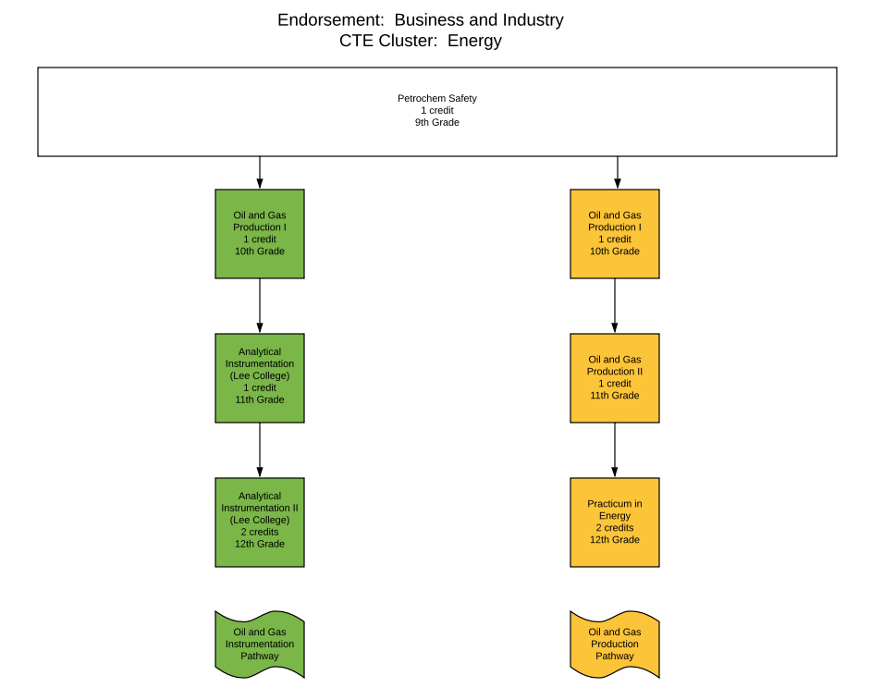

Endorsement: Business and Industry
CTE Cluster: Energy

 | Oil and Gas Instrumentation | Oil and Gas Production
9th Grade | Petrochem Safety  (1 credit) | Petrochem Safety  (1 credit)
10th Grade | Oil and Gas Production I  (1 credit) | Oil and Gas Production I  (1 credit)
11th Grade | Analytical Instrumentation I  (1 credits) | Oil and Gas Production II  (1 credit)
12th Grade | Analytical Instrumentation II  (2 credits) | Practicum in Energy  (2 credits)
Additional Courses
Certifications | Osha 30 hour | Osha 30 hour

CTE Cluster: Energy Course Descriptions

9th Grade Options:
- Petrochemical Safety Health and Environment provides opportunities for students to learn about environmentally sound work habits within the petrochemical industry.
Credit: 1 Prerequisite: Oil and Gas Production I

10th Grade Options:
- Oil and Gas Production I introduces students to specific career opportunities and skills, abilities, tools, certification, and safety measures associated with each career. Students will also understand components, systems, equipment, and production and safety regulations associated with oil and gas wells.
Credit: 1 Prerequisite: None

11th Grade Options:
- Oil and Gas Production II will allow students to gain knowledge of the specific requirements for entry into post-secondary education and employment in the petroleum industry; research and discuss petroleum economics; research and discuss the modes of transportation in the petroleum industry; research and discuss environmental, health, and safety concerns; research and discuss different energy sources; and prepare for industry certification.
Credit: 1 Prerequisite: Oil and Gas Production I
- Analytical Instrumentation I allows students to take 6 hours of college credit at Lee College by taking the following classes:
INTC 1312 | Instrumentation & Safety | 3
INTC 1307 | Instrumentation Test Equipment | 3
Credit: 1 Prerequisite: Acceptance into the Lee College Instrumentation Program

12th Grade Options:
- Practicum in Energy gives students supervised practical application of knowledge and skills. Practicum experiences can occur in a variety of locations appropriate to the nature and level of experiences such as employment, independent study, internships, assistantships, mentorships, or laboratories. The practicum course is a paid or unpaid capstone experience for students participating in a coherent sequence of career and technical education courses in the Energy Career Pathway.
Credit: 2 Prerequisite: Oil and Gas Production III
- Analytical Instrumentation II allows students to take 13 hours of college credit at Lee College by taking the following classes:
IEIR 1302 | Introduction to Direct Current Circuits | 3
CTEC 1401 | Applied Petrochemical Technology | 4
Math 0314 | Intermediate Algebra | 3
Math 1314 | College Algebra | 3
Credit: 2 Prerequisite: Acceptance into the Lee College Instrumentation Program and completion of the Lee College Instrumentation Program Year 1 courses

Endorsement: Public Service

CTE Cluster: Health Science

CTE Pathways:
Patient Care Technician Pathway
General Health Science Pathway
Pharmacy Technician Pathway
Emergency Medical Technician Pathway
Medical Assistant Pathway

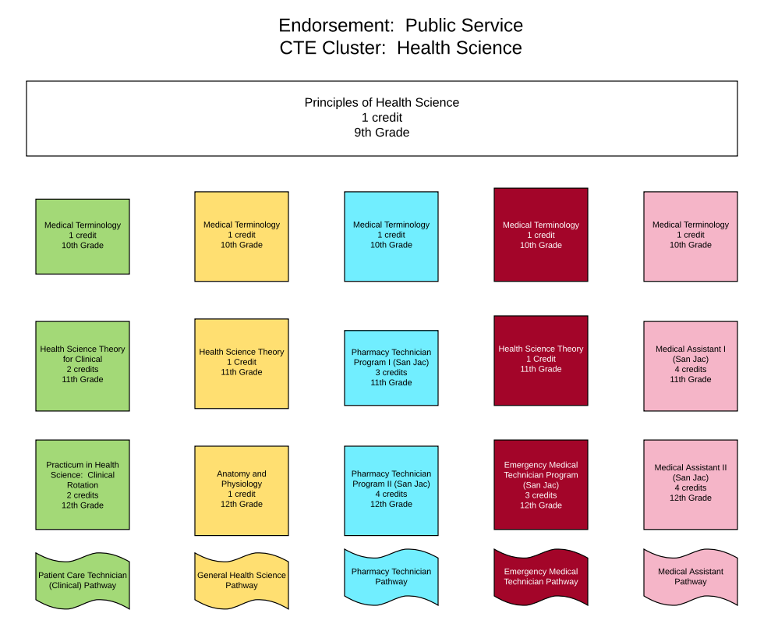

Endorsement: Public Service
CTE Cluster: Health Science

 | Patient Care Technician (Clinical) | General Health Science | Pharmacy Technician Pathway (San Jac) | Emergency Medical Technician Pathway (San Jac) | Medical Assistant Pathway (San Jac)
9th Grade | Principles of Health Science  (1 credit) | Principles of Health Science  (1 credit) | Principles of Health Science  (1 credit) | Principles of Health Science  (1 credit) | Principles of Health Science  (1 credit)
10th Grade | Medical Terminology  (1 credit) | Medical Terminology  (1 credit) | Medical Terminology  (1 credit) | Medical Terminology  (1 credit) | Medical Terminology  (1 credit)
11th Grade | Health Science Theory for Clinical Rotation  (2 credits) | Health Science Theory  (1 credit) | Pharmacy Technician Program I  at San Jacinto College | Health Science Theory  (1 credit) | Medical Assistant Program  at San Jacinto College
12th Grade | Practicum in Health Science Clinical Rotation (2 credits) | Anatomy and Physiology | Pharmacy Technician Program II  at San Jacinto College | Emergency Medical Technician  at San Jacinto College | Medical Assistant Program II  at San Jacinto College
Additional Courses | Anatomy and Physiology  (1 credit) |  | Anatomy and Physiology  (1 credit)
Certifications | Patient Care Technician |  | Pharmacy Technician | Emergency Medical Technician Basic | Clinical Medical Assistant

CTE Cluster: Health Science Course Descriptions

9th Grade Options:
- Principles of Health Science provides an overview of the therapeutic, diagnostic, health informatics, support services, and biotechnology research and development systems of the health care industry.
Credit: 1 Prerequisite: None

10th Grade Options:
- Medical Terminology introduces students to the structure of medical terms, including prefixes, suffixes, word roots, singular and plural forms, and medical abbreviations. The course allows students to achieve comprehension of medical vocabulary appropriate to medical procedures, human anatomy and physiology, and pathophysiology.
Credit: 1 Prerequisite: Principles of Health Science

11th Grade Options:
- Health Science Theory provides for the development of advanced knowledge and skills related to a wide variety of health careers. Students will employ hands-on experiences for continued knowledge and skill development.
Credit: 1 Prerequisite: Principles of Health Science and Medical Terminology
- Health Science Theory for Clinical provides for the development of advanced knowledge and skills related to a wide variety of health careers. Students will employ hands-on experiences for continued knowledge and skill development.
Credit: 2 Prerequisite: Principles of Health Science and Medical Terminology
- Pharmacy Technician Program I The pharmacy technician program at San Jacinto College is a nationally-accredited program under the guidelines of the American Society of Health-System Pharmacists and the Accreditation Council for Pharmacy Education (ASHP/ACPE). The program curriculum requires students to complete 32 credit hours that total 864 contact hours which consists of a combination of lecture, on-campus laboratory and clinical training. The emphasis of the program is on training students to work in retail and hospital pharmacies. Upon completion of the program, students are awarded a certificate of technology. After graduation, students register to take the National Certification Exam. A pharmacy technician must pass the certification examination and register with the Texas State Board of Pharmacy (TSBP) to practice as a certified pharmacy technician (CPhT) in the state of Texas. The program includes two clinical courses. Clinicals are unpaid positions in which students are supervised by the employees at the clinical site. Clinicals are scheduled according to the hours of the site and may vary among day, evening and night shifts. We cannot guarantee any specific site, but every effort will be made to accommodate the student. Students are responsible for their own transportation to and from clinical sites. Applicants for the program must meet the requirements for general admission to the College and must also meet program specific requirements. For detailed information concerning admission requirements and deadlines for submitting applications and related documents, contact the Pharmacy Technician Department.
Credit: 4 Prerequisite: Principles of Health Science and Medical Terminology, Acceptance into San Jacinto College Pharmacy Technician Program

- Medical Assistant Program I is designed to train medical assistant personnel to perform both administrative and clinical duties and to report directly to an office manager, physician, or other health practitioner. Administrative duties may include answering telephones, greeting patients, updating and filing patient medical records, filling out insurance forms, scheduling appointments, handling billing, and bookkeeping. Clinical duties vary according to state law but can include taking medical histories and recording vital signs, explaining treatment procedures to patients, preparing patients for examination, and assisting physicians during examination. Upon completion of the Medical Assisting program, the student is granted a certificate of technology and is eligible to sit for two exams. These include the AAMA Certification Examination to earn the Certified Medical Assistant, CMA (AAMA) and the Registered Medical Assistant Exam to earn the RMA (AMT) Certification.
Credit: 4 Prerequisite: Principles of Health Science and Medical Terminology, Acceptance into San Jacinto College Medical Assistant Program

12th Grade Options:
- Practicum in Health Science: Clinical Rotation provides students with a practical application of previously studied knowledge and skills. Practicum experiences can occur in a variety of locations appropriate to the nature and level of experience.
Credit: 2 Prerequisite: Principles of Health Science and Medical Terminology
- Anatomy and Physiology students to conduct laboratory and field investigations, use scientific methods during investigations, and make informed decisions using critical thinking and scientific problem solving. Students in Anatomy and Physiology will study a variety of topics, including the structure and function of the human body and the interaction of body systems for maintaining homeostasis.
Credit 1 Prerequisite: Biology, 2nd Science credit
- Pharmacy Technician Program II The pharmacy technician program at San Jacinto College is a nationally-accredited program under the guidelines of the American Society of Health-System Pharmacists and the Accreditation Council for Pharmacy Education (ASHP/ACPE). The program curriculum requires students to complete 32 credit hours that total 864 contact hours which consists of a combination of lecture, on-campus laboratory and clinical training. The emphasis of the program is on training students to work in retail and hospital pharmacies. Upon completion of the program, students are awarded a certificate of technology. After graduation, students register to take the National Certification Exam. A pharmacy technician must pass the certification examination and register with the Texas State Board of Pharmacy (TSBP) to practice as a certified pharmacy technician (CPhT) in the state of Texas. The program includes two clinical courses. Clinicals are unpaid positions in which students are supervised by the employees at the clinical site. Clinicals are scheduled according to the hours of the site and may vary among day, evening and night shifts. We cannot guarantee any specific site, but every effort will be made to accommodate the student. Students are responsible for their own transportation to and from clinical sites. Applicants for the program must meet the requirements for general admission to the College and must also meet program specific requirements. For detailed information concerning admission requirements and deadlines for submitting applications and related documents, contact the Pharmacy Technician Department.
Credit: 5 Prerequisite: Pharmacy Technician Program I, Acceptance into San Jacinto College Pharmacy Technician Program and completion of the Pharmacy Technician Program Year 1 courses

- Emergency Medical Technician The goal of the EMS Program at San Jacinto College is to prepare competent entry-level Emergency Medical Technicians and Paramedics in the cognitive (knowledge), psychomotor (skills), and affective (behavior) learning domains, with exit points at the Emergency Medical Technician-Intermediate, and Emergency Medical Technician-Basic levels. The emergency medical services (EMS) curriculum includes a combination of class lectures, skills training and clinical training in hospital and ambulance settings. The EMS program at San Jacinto College meets Texas Department of State Health Services (TDSHS) and the National Registry of EMT requirements for certification eligibility. Upon successful completion of the program, students registering for the emergency medical services program must meet TDSHS requirements and be eligible to take the National Registry of EMT certification examination. Applicants for the program must meet the requirements for general admission to the College and must also meet program specific requirements.
Credit: 3 Prerequisite: Principles of Health Science, Medical Terminology, and Health Science Theory, Acceptance into San Jacinto College Emergency Medical Technician Program

- Medical Assistant Program II is designed to train medical assistant personnel to perform both administrative and clinical duties and to report directly to an office manager, physician, or other health practitioner. Administrative duties may include answering telephones, greeting patients, updating and filing patient medical records, filling out insurance forms, scheduling appointments, handling billing, and bookkeeping. Clinical duties vary according to state law but can include taking medical histories and recording vital signs, explaining treatment procedures to patients, preparing patients for examination, and assisting physicians during examination. Upon completion of the Medical Assisting program, the student is granted a certificate of technology and is eligible to sit for two exams. These include the AAMA Certification Examination to earn the Certified Medical Assistant, CMA (AAMA) and the Registered Medical Assistant Exam to earn the RMA (AMT) Certification.
Credit: 5 Prerequisite: Medical Assistant Program I, Acceptance into San Jacinto College Medical Assistant Program and Completion of the Medical Assistant Year 1 Program courses

Endorsement: Business and Industry

CTE Cluster: Hospitality and Tourisms

CTE Pathways:
Culinary Pathway

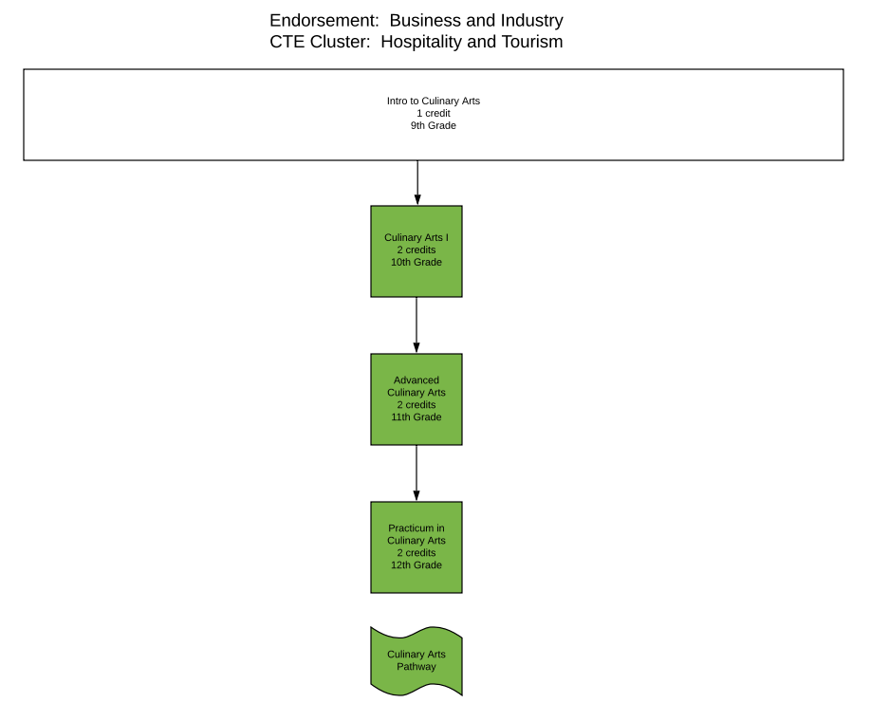

Endorsement: Business and Industry
CTE Cluster: Hospitality and Tourism

 | Culinary
9th Grade | Intro to Culinary Arts  (1 credits)
10th Grade | Culinary Arts I  (2 credits)
11th Grade | Advanced Culinary Arts  (2 credits)
12th Grade | Practicum in Culinary Arts I  (2 credits)
Additional Courses
Certifications | ServSafe Manager

CTE Cluster: Hospitality and Tourism Course Descriptions

9th Grade Options:
- Intro to Culinary Arts provides students an insight into food production skills, various levels of industry management, and hospitality skills. This is an entry level course for students interested in pursuing a career in the food service industry. This course is offered as a classroom and laboratory-based course.
Credit: 1 Prerequisite: None

10th Grade Options:
- Culinary Arts I will allow students to learn the fundamentals and principles of the art of cooking and the science of baking and includes management and production skills and techniques. Students can pursue a national sanitation certification or other appropriate industry certifications.
Credit: 2 Prerequisite: Principles of Hospitality and Tourism

11th Grade Options:
- Advanced Culinary Arts will extend content and enhance skills introduced in Culinary Arts by in-depth instruction of industry-driven standards to prepare students for success in higher education, certifications, and/or immediate employment.
Credit: 2 Prerequisite: Culinary Arts I

12th Grade Options:
- Practicum in Culinary Arts is a unique practicum that provides occupationally specific opportunities for students to participate in a learning experience that combines classroom instruction with actual business and industry career experiences. Practicum in Culinary Arts integrates academic and career and technical education; provides more interdisciplinary instruction; and supports strong partnerships among schools, businesses, and community institutions with the goal of preparing students with a variety of skills in a fast-changing culinary art based workplace.
Credit: 2 Prerequisite: Advanced Culinary Arts

Endorsement: Business and Industry

CTE Cluster: Human Services

CTE Pathways:
Cosmetology Pathway

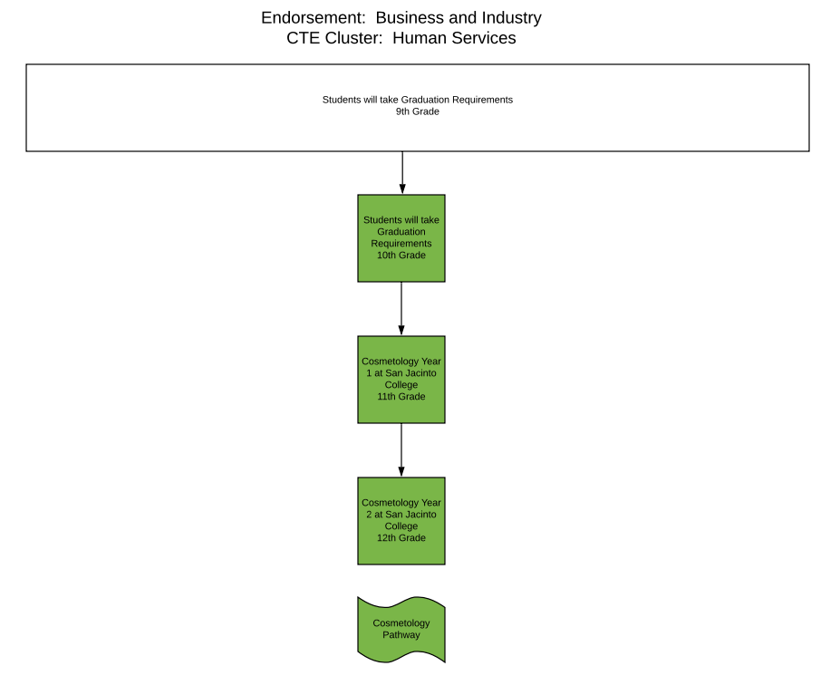

Endorsement: Business and Industry
CTE Cluster: Human Services

 | Cosmetology
9th Grade | Students will take Graduation Requirements
10th Grade | Students will take Graduation Requirements
11th Grade | Cosmetology Program Year 1
12th Grade | Cosmetology Program Year 2
Additional Courses
Certifications | Cosmetology Operator License

CTE Cluster: Hospitality and Tourism Course Descriptions

9th Grade Options:
Students will take electives needed to meet graduation requirements

10th Grade Options:
Students will take electives needed to meet graduation requirements

11th Grade Options:
- Cosmetology Program Year 1 allows students to earn 16 college credits by taking the following classes:
CSME 1310 | Introduction to Haircutting and Related Theory | 3
CSME 1505 | Fundamentals of Cosmetology | 5
CSME 1553 | Chemical Reformation and Related Theory | 5
CSME 1354 | Artistry of Hair Design I | 3
Credit: 3 Prerequisite: Acceptance into San Jacinto College’s Cosmetology Program

12th Grade Options:
- Cosmetology Program Year 2 allows students to earn 16 college credits by taking the following classes:
CSME 1355 | Artistry of Hair Design II | 3
CSME 2501 | Principles of Hair Coloring and Related Theory | 5
CSME 2310 | Advanced Haircutting and Related Theory | 3
CSME 2350 | Preparation for the State Licensing Written Examination | 3
CSME 2251 | Preparation for the State Licensing Practical Examination | 2

Credit: 3 Prerequisite: Acceptance into San Jacinto College’s Cosmetology Program

Endorsement: Public Service

CTE Cluster: Law and Public Service

CTE Pathways:
Criminal Justice Pathway

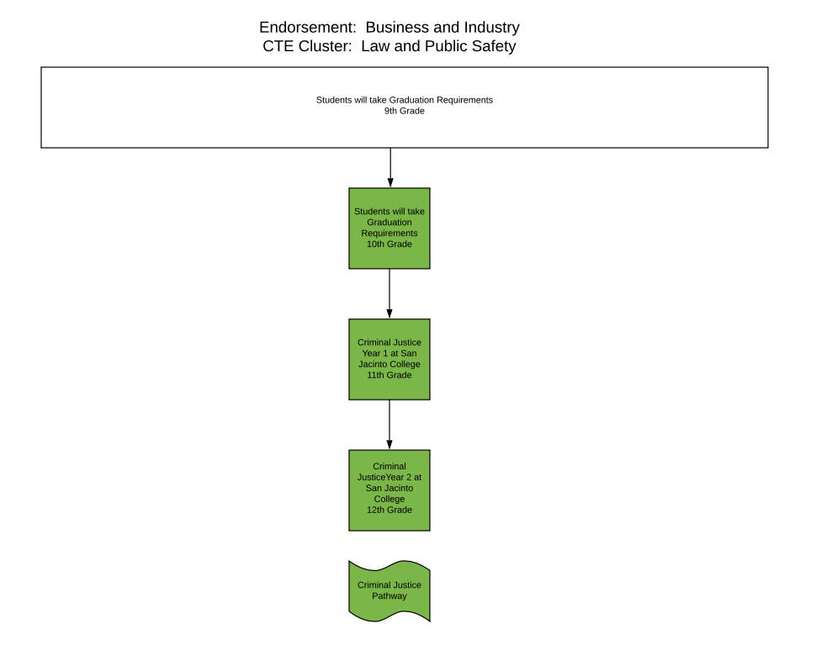

Endorsement: Business and Industry
CTE Cluster: Law and Public Safety

 | Criminal Justice
9th Grade | Students will take Graduation Requirements
10th Grade | Students will take Graduation Requirements
11th Grade | Criminal Justice Program Year 1
12th Grade | Criminal Justice Program Year 2
Additional Courses
Certifications

CTE Cluster: Law and Public Safety Course Descriptions

9th Grade Options:
Students will take electives needed to meet graduation requirements

10th Grade Options:
Students will take electives needed to meet graduation requirements

11th Grade Options:
- Criminal Justice Program Year 1 allows students to earn 15 college credits by taking the following classes:
CRIJ 1301/CJSA 1322 | Introduction to Criminal Justice | 3
CRIJ 1306/CJSA 1313 | Court Systems and Practices | 3
CRIJ 1310/CJSA 1327 | Fundamentals of Criminal Law | 3
CRIJ 2313/CJCR 1307 | Correctional Systems and Practices | 3
CRIJ 2328/CJSA 1359 | Police Systems and Practices | 3
Credit: 2.5 Prerequisite: Acceptance into San Jacinto College’s Criminal Justice Program

12th Grade Options:
- Criminal Justice Program Year 2 allows students to earn 15 college credits by taking the following classes:
CRIJ 1307/CJSA 1312 | Crime in America | 3
CJLE 1327 | Interviewing and Report Writing for Criminal Justice Professions | 3
CRIJ 2323/CJSA 2300 | Legal Aspects of Law Enforcement | 3
CRIJ 2314/CJSA 1342 | Criminal Investigation | 3
CJSA 1348 | Ethics in Criminal Justice | 3
Credit: 2.5 Prerequisite: Acceptance into San Jacinto College’s Criminal Justice Program

Endorsement: Business and Industry

CTE Cluster: Manufacturing (Welding)

CTE Pathways:
Welding Pathway

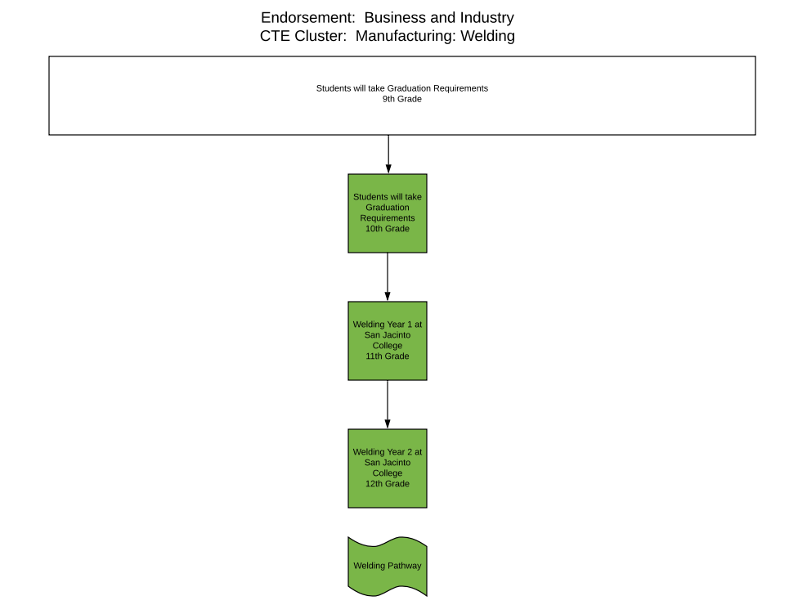

Endorsement: Business and Industry
CTE Cluster: Manufacturing: Welding

 | Welding Pathway
9th Grade | Students will take Electives for Graduation Requirements
10th Grade | Students will take Electives for Graduation Requirements
11th Grade | Welding Program Year 1  (3 credits)
12th Grade | Practicum in Manufacturing: Welding  (3 credits)
Additional Courses
Certifications | NCCER Welding

CTE Cluster: Manufacturing: Welding Course Descriptions

9th Grade Options:
Students will take electives needed to meet graduation requirements

10th Grade Options:
Students will take electives needed to meet graduation requirements

11th Grade Options:
- Welding Program Year 1 allows students to earn 12 college credits by taking the following classes:
WLDG 1428 | Introduction to Shielded Metal Arc Welding (SMAW) | 4
WLDG 2443 | Advanced Shielded Metal Arc Welding (SMAW) | 4
WLDG 1434 | Introduction to Gas Tungsten Arc Welding (GTAW) | 4
Credit: 3 Prerequisite: Acceptance into San Jacinto College’s Criminal Justice Program

12th Grade Options:
- Criminal Justice Program Year 2 allows students to earn 12 college credits by taking the following classes:
WLDG 2406 | Intermediate Pipe Welding | 4
WLDG 2453 | Advanced Pipe Welding | 4
WLDG 2451 | Advanced Gas Tungsten Arc Welding (GTAW) | 4
Credit: 3 Prerequisite: Acceptance into San Jacinto College’s Criminal Justice Program

Endorsement: STEM

CTE Cluster: STEM Manufacturing

CTE Pathways:
Robotics Pathway

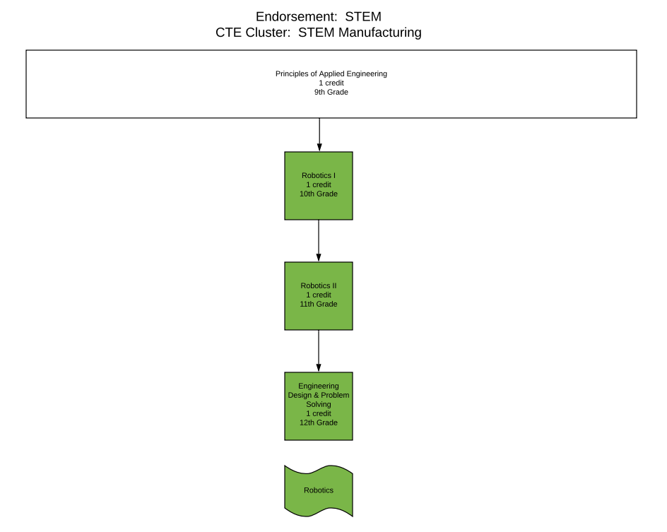

Endorsement: STEM
CTE Cluster: STEM Manufacturing

 | Robotics Pathway
9th Grade | Principles of Applied Engineering  (1 credit)
10th Grade | Robotics I  (1 credit)
11th Grade | Robotics II  (1 credit)
12th Grade | Engineering Design and Problem Solving **  (1 credit)
Additional Courses
Certifications | Oracle Certified Associate

** Engineering Design and Problem Solving can count as a 4th Science Credit

CTE Cluster: STEM Manufacturing Robotics Course Descriptions

9th Grade Options:
- Principles of Applied Engineering provides an overview of the various fields of science, technology, engineering, and mathematics and their interrelationships. Students will develop engineering communication skills, which include computer graphics, modeling, and presentations, by using a variety of computer hardware and software applications to complete assignments and projects. Upon completing this course, students will understand the various fields of engineering and will be able to make informed career decisions. Further, students will have worked on a design team to develop a product or system. Students will use multiple software applications to prepare and present course assignments.
Credit: 1 Prerequisite: None

10th Grade Options:
- Robotics students will learn the academic skills needed to component designs in a project-based environment through implementation of the design process. Students will build prototypes or use simulation software to test their designs. Additionally, students will explore career opportunities, employer expectations, and educational needs in the robotic and automation industry.
Credit: 1 Prerequisite: Principles of Applied Engineering

11th Grade Options:
- Robotics II students will explore artificial intelligence and programming in the robotic and automation industry. Through implementation of the design process, students will transfer academic skills to component designs in a project-based environment. Students will build prototypes and use software to test their designs.
Credit: 1 Prerequisite: Robotics I

12th Grade Options:
- Engineering Design and Problem Solving is the creative process of solving problems by identifying needs and then devising solutions. The solution may be a product, technique, structure, or process depending on the problem. Science aims to understand the natural world, while engineering seeks to shape this world to meet human needs and wants. Engineering design takes into consideration limiting factors or "design under constraint." Various engineering disciplines address a broad spectrum of design problems using specific concepts from the sciences and mathematics to derive a solution. The design process and problem solving are inherent to all engineering disciplines. This course satisfies a high school science graduation requirement.
Credit: 1 Prerequisite: Algebra I, Geometry, Principles of Applied Engineering, Robotics I, and Robotics II

Endorsement: STEM

CTE Cluster: STEM Computer Science

CTE Pathways:
Computer Programming Pathway

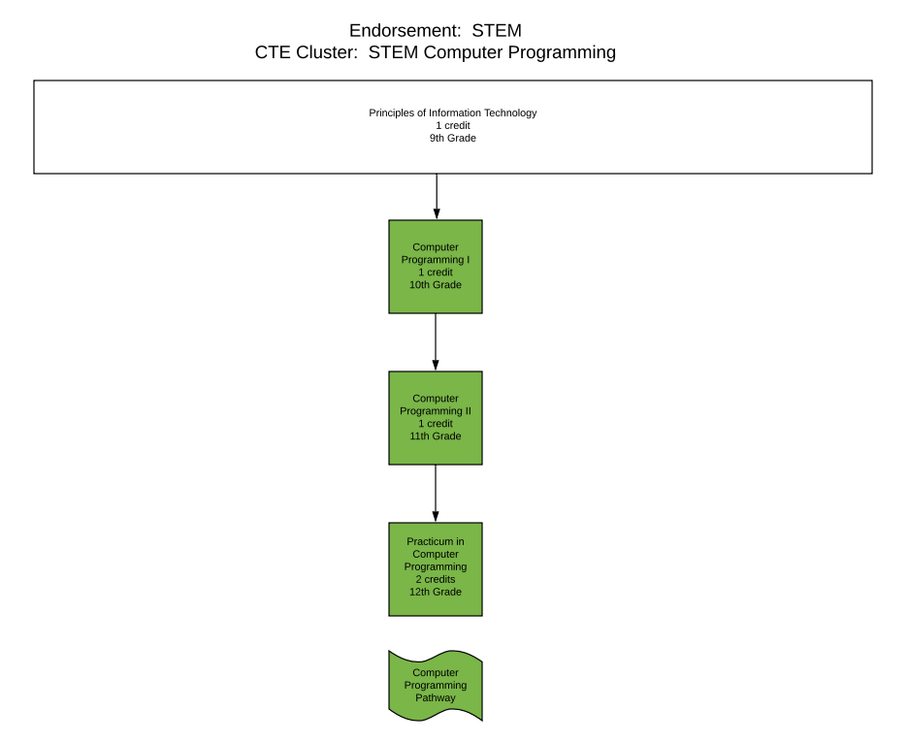

Endorsement: STEM
CTE Cluster: STEM: Computer Programming

 | Computer Programming Pathway
9th Grade | Principles of Information Technology  (1 credit)
10th Grade | Computer Programming I  (1 credit)
11th Grade | Computer Programming II  (1 credit)
12th Grade | Practicum in Information Technology: Computer Programming or Cyber Security TBD  (2 credits)
Additional Courses | OnRamps Computer Science  (1 credit)
Certifications | Oracle Certified Associate

CTE Cluster: STEM Computer Programming Course Descriptions

9th Grade Options:
- Principles of Information Technology students will develop computer literacy skills to adapt to emerging technologies used in the global marketplace. Students will implement personal and interpersonal skills to prepare for a rapidly evolving workplace environment. Students will enhance reading, writing, computing, communication, and reasoning skills and apply them to the information technology environment.
Credit: 1 Prerequisite: None

10th Grade Options:
- Computer Programming I will allow students to acquire knowledge of structured programming techniques and concepts appropriate to developing executable programs and creating appropriate documentation. Students will analyze the social responsibility of business and industry regarding the significant issues relating to the environment, ethics, health, safety, and diversity in society and in the workplace as related to computer programming.
Credit: 1 Prerequisite: Principles of Information Technology

11th Grade Options:
- Computer Programming II will extend content and enhance skills introduced in Computer Programming I by addressing more complex problems and developing comprehensive programming solutions. Students will analyze the social responsibility of business and industry regarding the significant issues relating to environment, ethics, health, safety, and diversity in society and in the workplace as related to computer programming. Students will apply technical skills to address business applications of emerging technologies.
Credit: 2 Prerequisite: Culinary Arts I

12th Grade Options:
- Practicum in Information students will gain advanced knowledge and skills in the application, design, production, implementation, maintenance, evaluation, and assessment of products, services, and systems. Knowledge and skills in the proper use of analytical skills and application of IT concepts and standards are essential to prepare students for success in a technology-driven society. Critical thinking, IT experience, and product development may be conducted in a classroom setting with an industry mentor, as an unpaid or paid internship, as part of a capstone project, or as career preparation.
Credit: 2 Prerequisite: Advanced Culinary Arts

Additional Course Options 10-12
- OnRamps Computer Science provides students an overview of the history and structure of the digital computer, including binary data representation. Problem solving, algorithm development, structured programming, good coding style, and control structures of C++ are emphasized.
Credit: 1 Prerequisite: Algebra I

Endorsement: Business and Industry

CTE Cluster: Transportation, Distribution, and Logistics

CTE Pathways:
Collision Repair Pathway
Diesel Technology Pathway

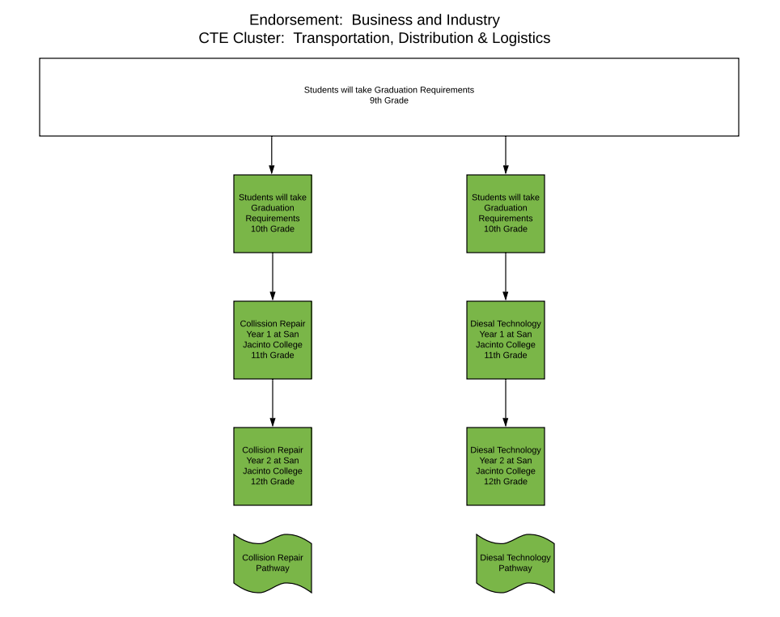

Endorsement: Business and Industry
CTE Cluster: Transportation, Distribution & Logistics

 | Collision Repair Pathway | Diesel Technology
9th Grade | Students will take Electives for Graduation Requirements | Students will take Electives for Graduation Requirements
10th Grade | Students will take Electives for Graduation Requirements | Students will take Electives for Graduation Requirements
11th Grade | Collision Repair Program Year 1  (4 credits) | Diesel Technology Program Year 1  (2 credits)
12th Grade | Collision Repair Program Year 2  (4 credits) | Diesel Technology Program Year 2  (4 credits)
Additional Courses
Certifications

CTE Cluster: Transportation, Distribution & Logistics Course Descriptions

9th Grade Options:
Students will take electives needed to meet graduation requirements

10th Grade Options:
Students will take electives needed to meet graduation requirements

11th Grade Options:
- Collision Repair Program Year 1 allows students to earn 30 college credits by taking the following classes:
ABDR 1307 | Collision Repair Welding | 3
ABDR 1519 | Basic Metal Repair | 5
ABDR 1431 | Basic Refinishing | 4
ABDR 1303 | Vehicle Design and Structural Analysis | 3
ABDR 2541 | Major Collision Repair and Panel Replacement | 5
ABDR 1441 | Structural Analysis and Damage Report I | 4
ABDR 2353 | Color Analysis and Paint Matching | 3
ABDR 1315 | Vehicle Trim and Hardware | 3
Credit: 4 Prerequisite: Acceptance into San Jacinto College’s Collision Repair Program
- Diesel Technology Program Year 1 allows students to earn 15 college credits by taking the following classes:
DEMR 1306 | Diesel Engine I | 3
DEMR 1405 | Basic Electrical Systems | 4
DEMR 1410 | Diesel Engine Testing and Repair I | 4
DEMR 1423 | Heating, Ventilation, and Air Conditioning (HVAC) Troubleshooting and Repair | 4
Credit: 3 Prerequisite: Acceptance into San Jacinto College’s Diesel Technology Program

12th Grade Options:
- Collision Repair Program Year 2 allows students to earn 12 college credits by taking the following classes:
ABDR 2502 | Auto Body Mechanical and Electrical Service | 5
ABDR 2255 | Collision Repair Estimating | 2
ABDR 2257 | Collision Shop Management | 2
ABDR 1323  or ABDR 2380 | Front and Rear Wheel Alignment  or Cooperative Education - Autobody/Collision and Repair Technology | 3
Credit: 4 Prerequisite: Acceptance into San Jacinto College’s Collision Repair Program and completion of Collision Repair Program Year 1 courses

- Diesel Technology Program Year 2 allows students to earn 14 college credits by taking the following classes:
DEMR 1301 | Shop Safety and Procedures | 3
DEMR 1413 | Fuel Systems | 4
DEMR 1317 | Basic Brake Systems | 3
DEMR 2432 | Electronic Controls | 4
Credit: 4 Prerequisite: Acceptance into San Jacinto College’s Diesel Technology Program and completion of the Diesel Technology Program Year 1 courses

